

RESUME

NITANT MAHAJU | REPORT| 2017/04/

# Introduction

Before I got in to making my resume, I took an example form different other people’s resume in the internet and got some relevant ideas about how I could make my own stylist resume. During the research I got some common ideas like they were using java, Bootstrap etc. And I ended up thinking I will use HTML and CSS, during the length of 12 weeks I had learned many things which helped me in creating my resume. The websites that gave some ideas to make my resume were:

* <http://wix.com/>

# Designs

### Wireframes

#### This is my wireframe for my homepage (index page).

Header

Navigation bar

“ABOUT ME”

Link to my CV

Link to my biography

Link to my contact

Footer

#### This is my wireframe for my CV page.

Header

Navigation bar

Photo

Footer

#### This is my wireframe for my biography page.

Header

Navigation bar

Footer

#### This is my wireframe for my contact page.

Header

Navigation bar

Contact form

Footer

### Sketches

#### Homepage sketches

During my research I found many attractive design and I wanted to make my homepage simple but effective and which should not make hard to the user to use it. In my homepage I will add a name in upper left corner of the page. I will use my picture as background image and make it fix. I will have a box with the opacity and keep there the link to my other pages. I will have footer at the bottom of the page and also the social media icon will be there with the 360 rotation animation effect. The navigation bar will be the gradient colour.

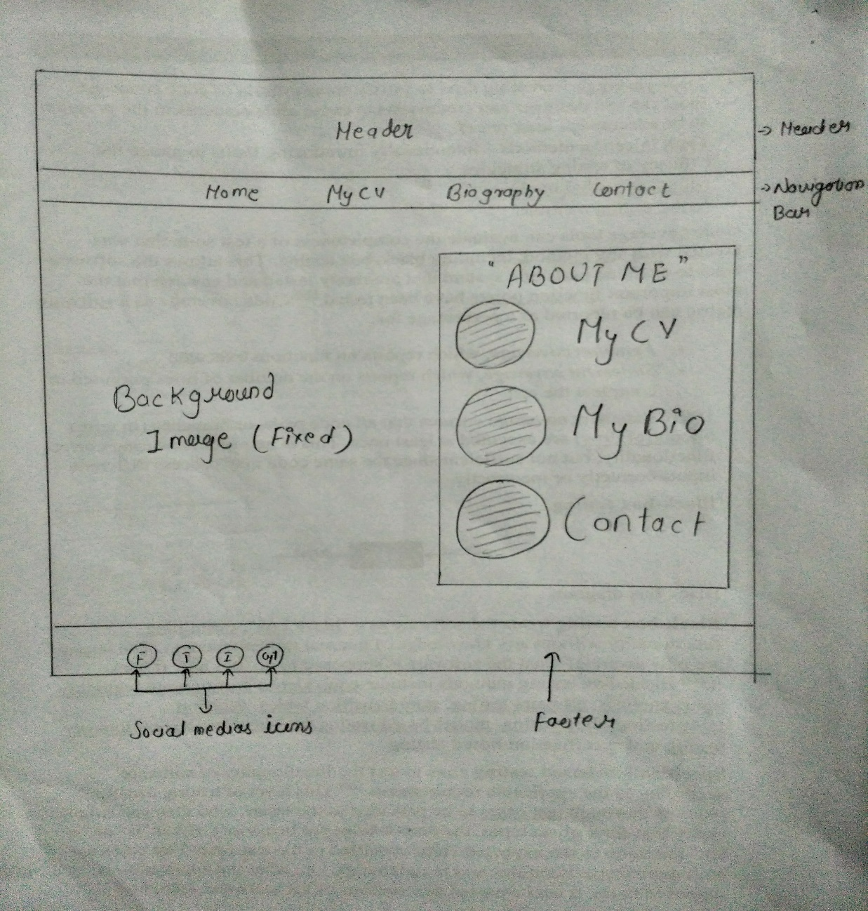

### CV page sketches

The navigation bar is the same which I will be including on respective page at the top. There will be a picture of me in a circular form which enlarges when it is hovered. There will be the skill section where the percentage of skill will be shown.

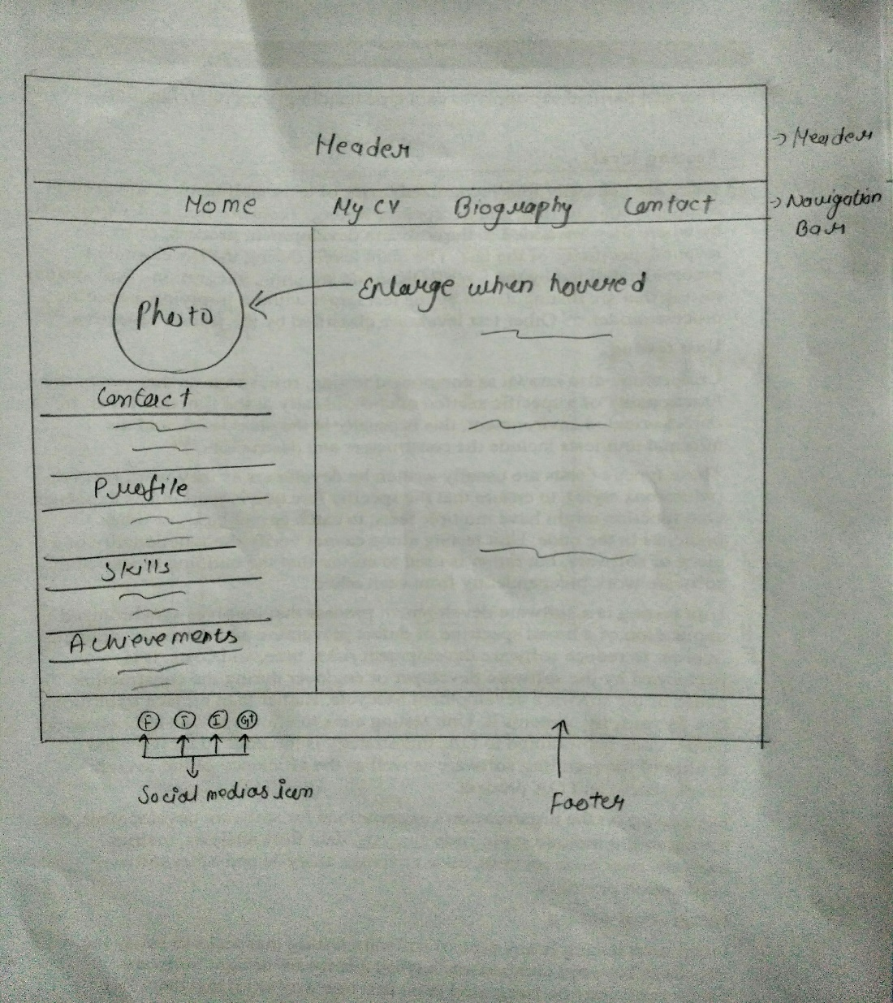

### Biography page sketches

On this page I will have a text box with the opacity. And will contain a background image of my friends which is fixed. There will be social media icon with respect to the text box. The navigation bar and footer will be the same as other page.

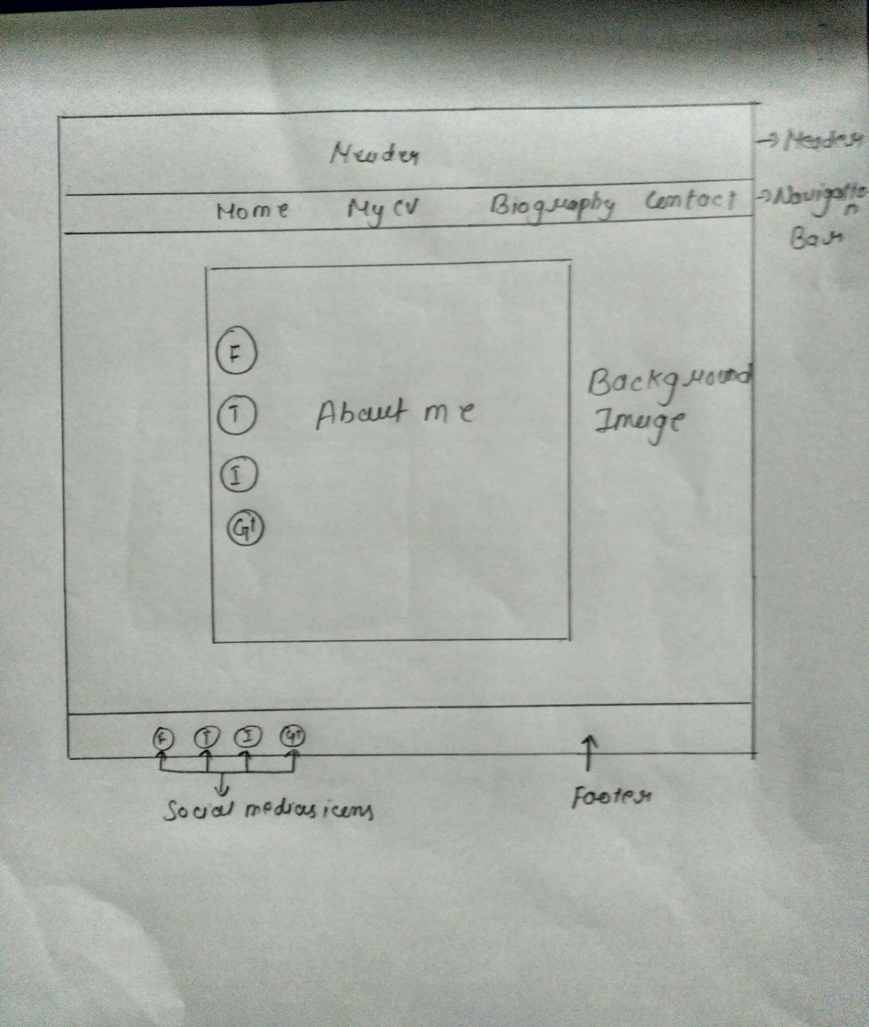

### Contact page sketches

The contact page of mine will be simple and attractive. The navigation and footer section is same as other pages. The background colour of the page will be black. And the form is there for

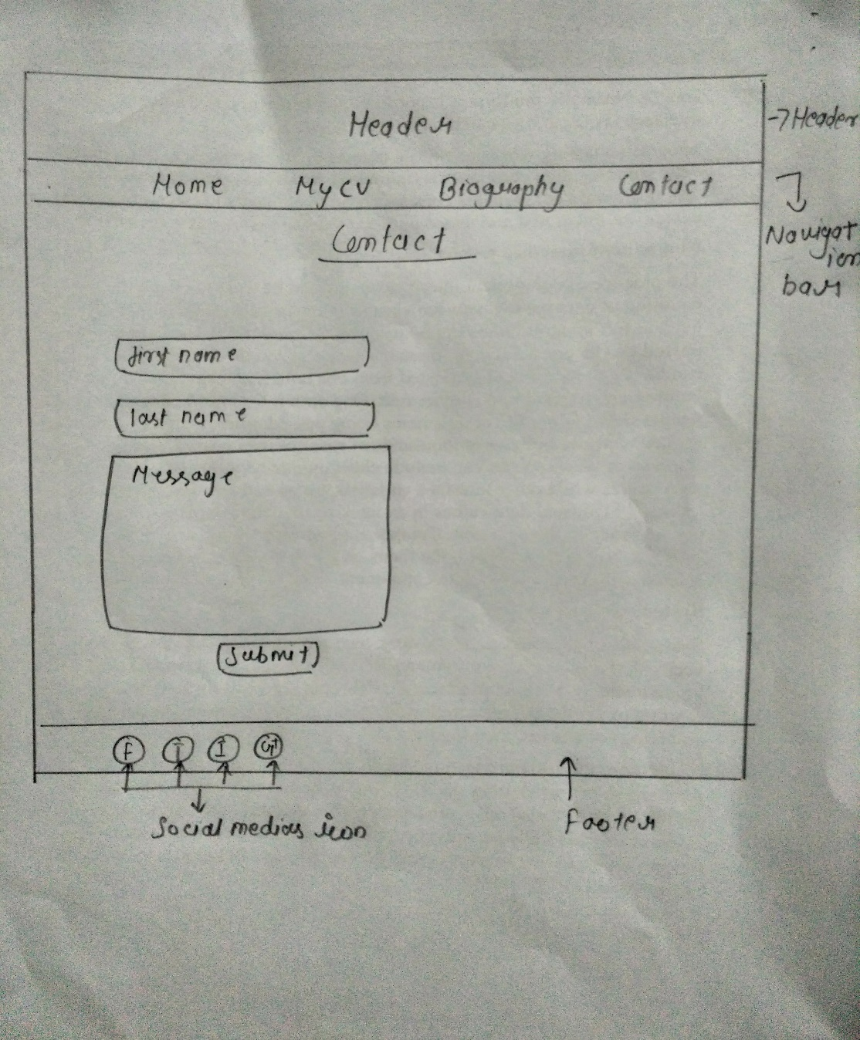

# Modes of good practice

## speed of pages

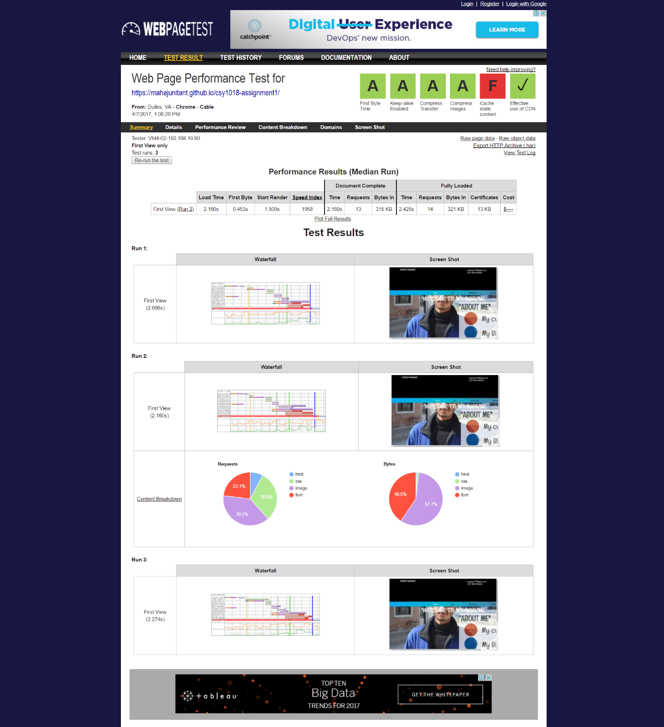

From this screenshot it can be concluded that the webpage is faster than most of the other sites which gives an edge to this website so it can be accessed easily by the user even with slow internet connection.

## ui (interface for users)

While I was creating my website I was also exploring other online resume or websites people have tried their best to create and looked for what was most popular, and attracting the user by looking in the interface of their websites. As I looked their websites I have tried my best to make my website to look relevant and dynamic but the simple one. For making this website my family and colleagues gave me suggestion for the website. So the website is simple as it looks but is attractive in its own presence.

# Webpage design

## Screen shot of webpages

### Homepage

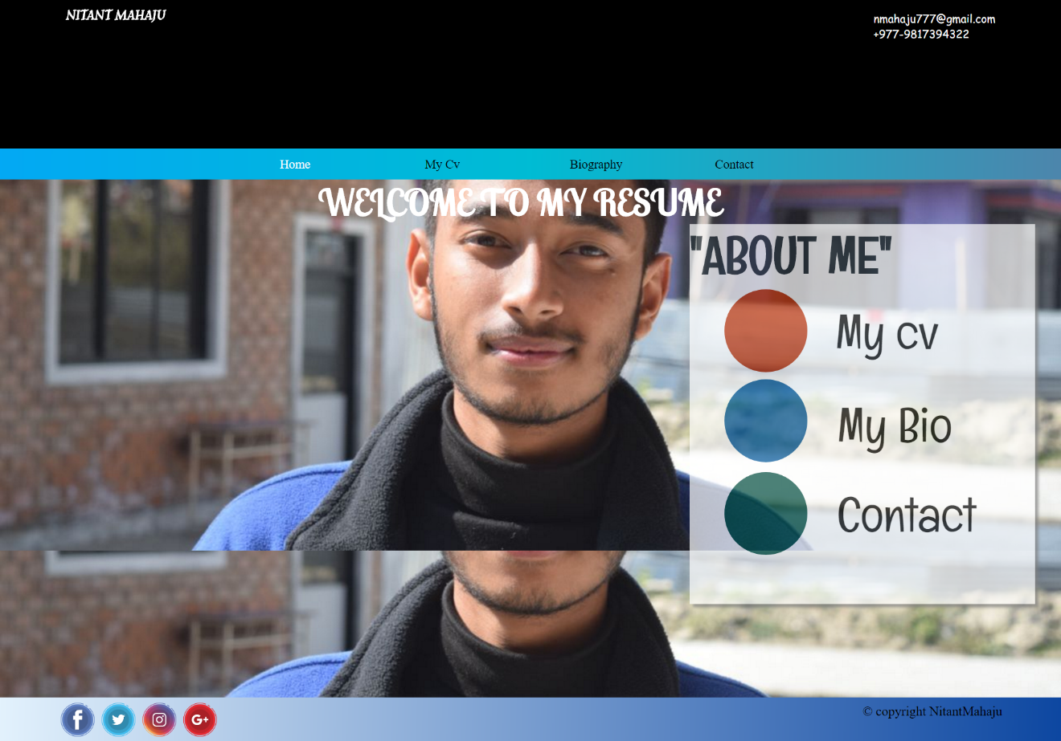

The above page is my homepage, I have used Html and Css for making it. This page contains header in which there is my name and address, whenever the user clicks the name in the upper left corner it sends the user back to the homepage. The navigation bar consist of home, my CV, biography and contact content in which the selected content changes in to white when selected. The color used in navigation bar is gradient which the mixture of three color is. The section contains of background image in this page is fixed, the background image repeated when it was screen shot. There is a box which is given opacity. There are three circles each circles consist of the content that content is linked to other pages when clicked the user goes to the respective link. The footer consist of simple social media’s icons which rotates when hovered by the user and there the copyright section too in the footer section.

### CV page

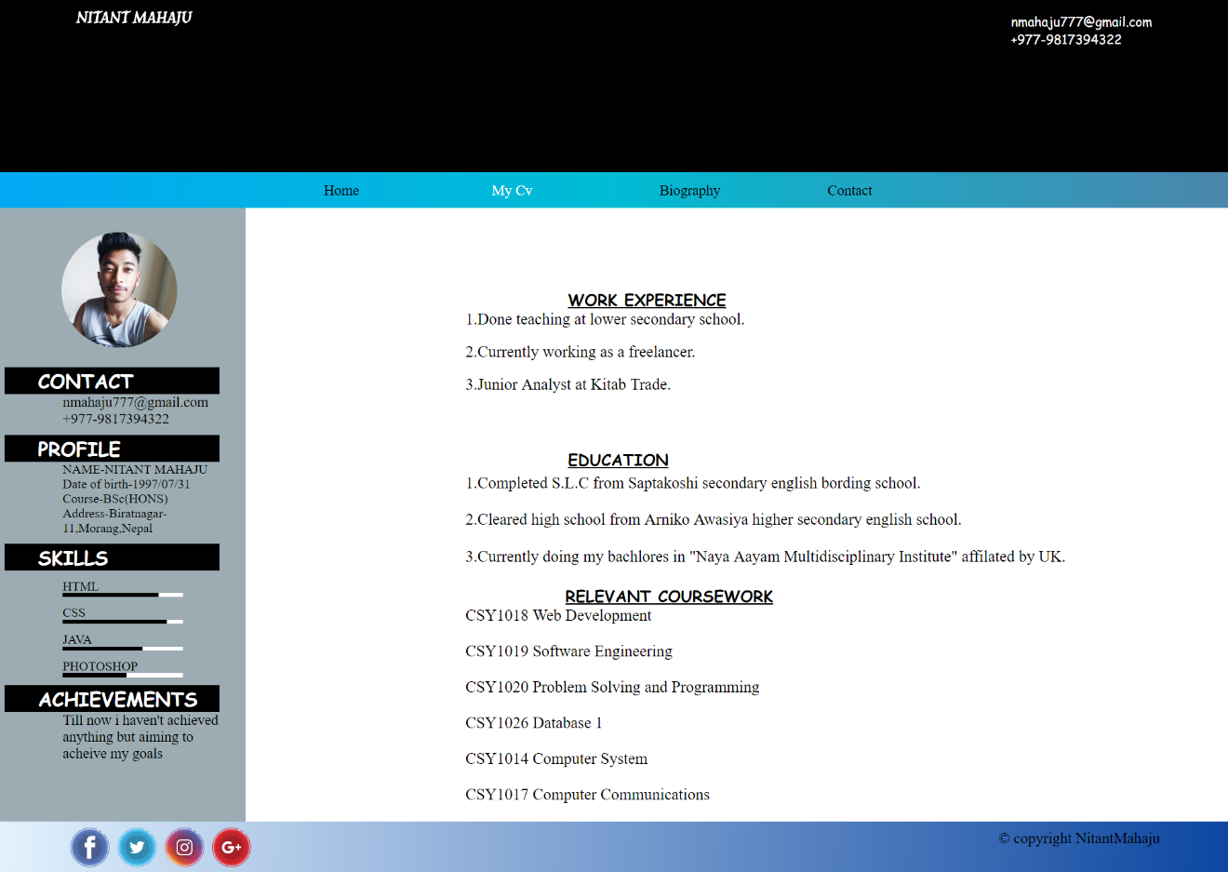

This is the CV page of my website, there is the header which consist of name and address in the left upper corner there is the name and in the right upper corner there is the address of mine and phone number. The name in the upper left corner when clicked the user will automatically go to the first page of the website which is the homepage. The navigation bar consist of same as explained in the homepage section. There is no background image in this page. The section is divided in to two parts one for the profile and another for the experience and education. As you can see there is a photo of me when the user hovers there the photo enlarges with the transition of 2s, the contact section contains my address, profile section contains about me, skill section contains what I am good and average at. As it is explained in the above content of the achievements I haven’t achieved anything. The footer contains social medias which have animation of rotation when hovered the icons rotates 360degree.

### Biography page

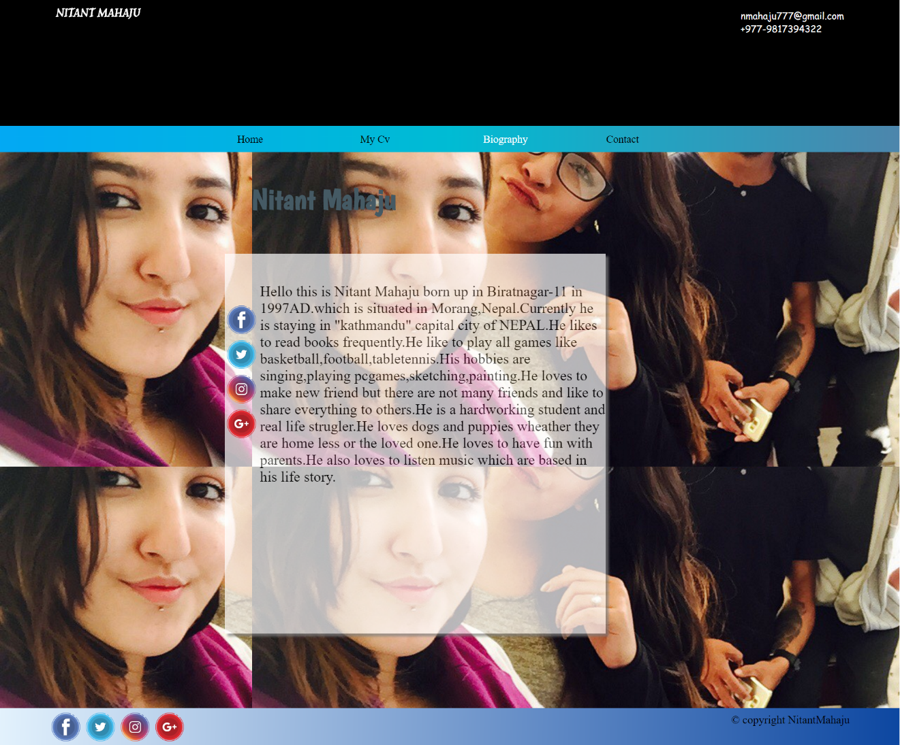

Above page is the biography page of my website, which consist of the header the header contains name and address of me. The name when clicked by the user takes the user back to the homepage. There is the navigation bar which consist of same as explained in the homepage. The section contains the background image of my (friends but don’t know when I screen shot the page the background image repeated). There is the box with the opacity and also the social media’s icon which have the animation of rotating about 360degree when the user hovered. The footer contains the social media icons which when the user hovers the icon rotates one full circle and there is the copyright section too.

### Contact page

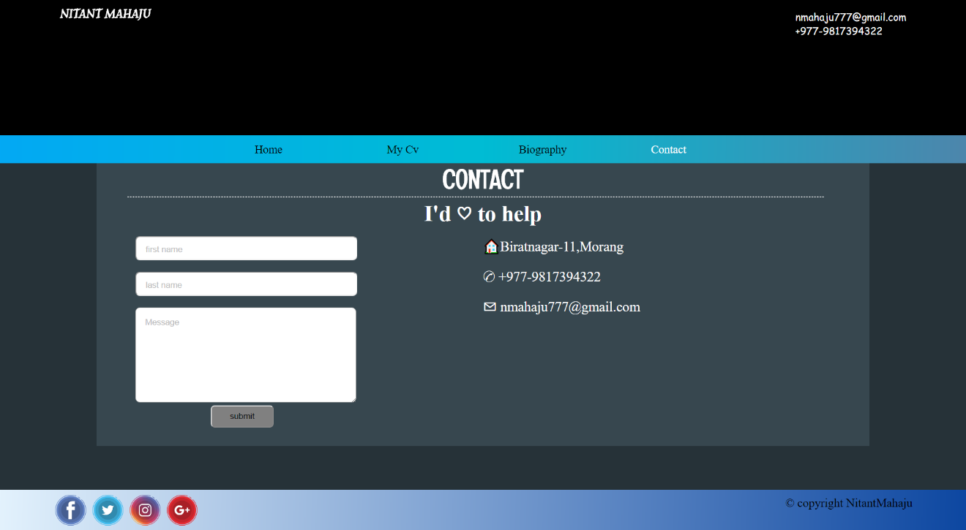

This is the contact page of my website, the header consist of name and address of me. The name in the left upper side corner and the upper right corner consist of the address. The name when clicked takes the user back to the homepage. The navigation bar contains the same as I have explained in the homepage. The section contains background colour “black”. In the section I have kept a box which looks like a form that consist of text box the user can write respective instruction given in the text box container. There is the submit button which when clicked the information gets submit.

## Responsive pages of website

### Homepage

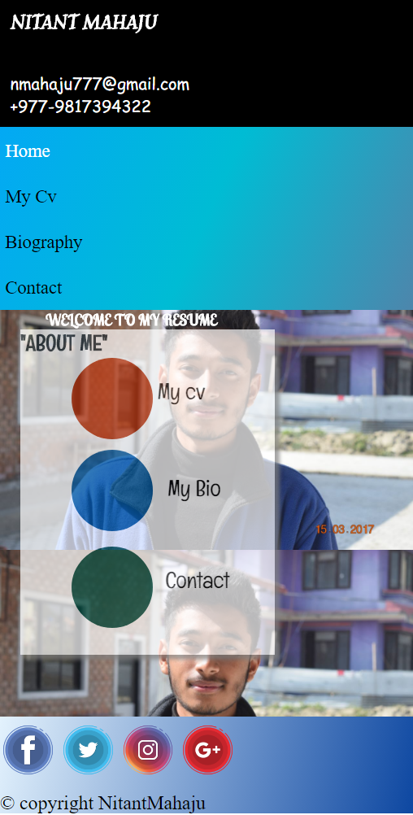

This is the responsive of the homepage. The header when contracts the contents displays as vertical as it was displayed horizontally. The navigation bar which was displayed horizontally is now displayed in vertical as it was contract. The box which was at the right side of the section is now at the left side of the section. (Don’t know why the background image when contracted it repeated). The footer when contracted the icon goes up in the footer and the copyright content comes below the social media’s icon.

### CV page

Above page is the responsive CV page, the header when contracts the contents displays as vertical as it was displayed horizontally. The navigation bar which was displayed horizontally is now displayed in vertical as it was contract. The section which was divided in to two division but now it is aligned vertically. The footer when contracted the icon goes up in the footer and the copyright content comes below the social media’s icon.

### Biography page

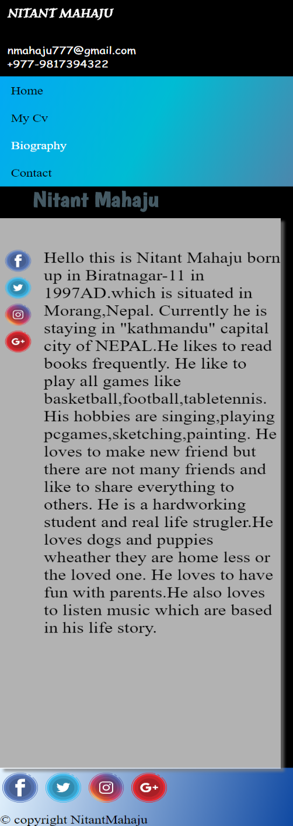

This is the biography page of my website, the header when contracts the contents displays as vertical as it was displayed horizontally. The navigation bar which was displayed horizontally is now displayed in vertical as it was contract. The section contains a box with opacity. The footer when contracted the icon goes up in the footer and the copyright content comes below the social media’s icon.

### Contact page

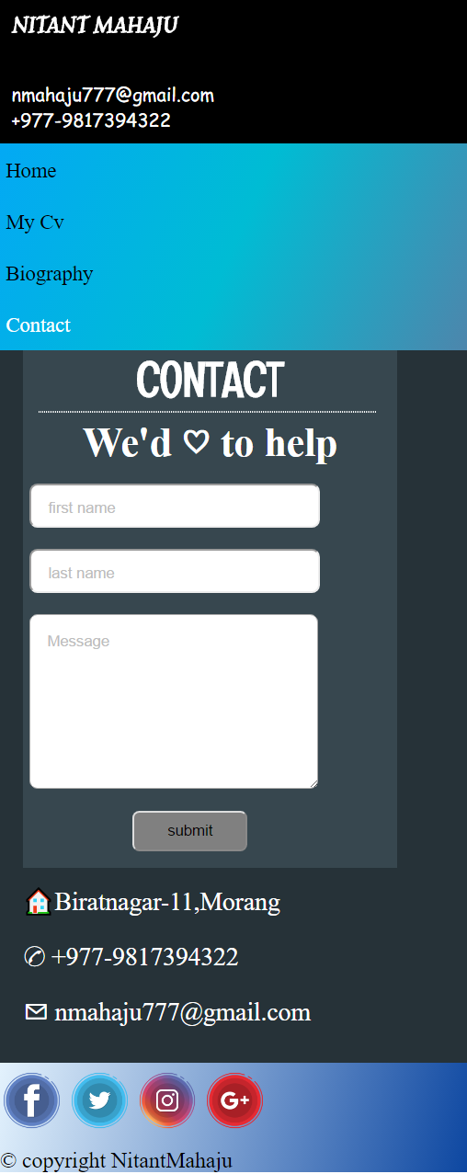

The above page is responsive page of contact page, the header when contracts the contents displays as vertical as it was displayed horizontally. The navigation bar which was displayed horizontally is now displayed in vertical as it was contract. The section consist of two parts one is form and another is the address part which when contract is displayed below the form. The footer when contracted the icon goes up in the footer and the copyright content comes below the social media’s icon.

## testing evaluation

### Test of html code of the webpages

##### Homepage

During the validation I found some errors and omit it and there was no warning too. So, the result is below as given.

##### CV page

During the test for the validation of the codes I found some errors and omitted it and there was no warning as you can see in the given below image.

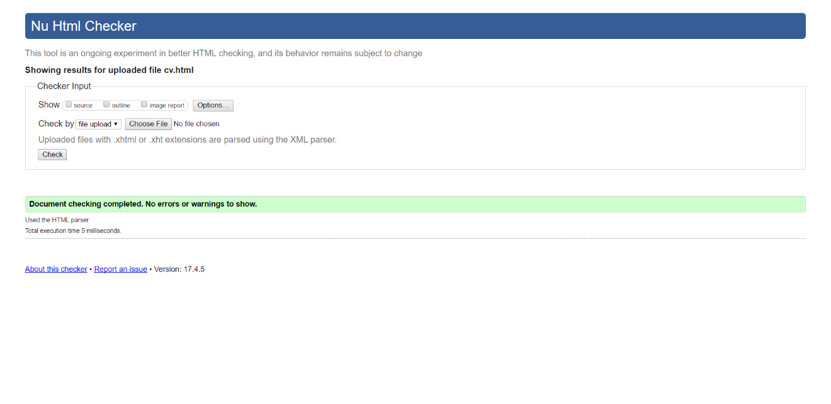

##### Biography page

During the validation test I got some errors but no warning was there seen and the errors that was there I omitted them and the results you can see them below.

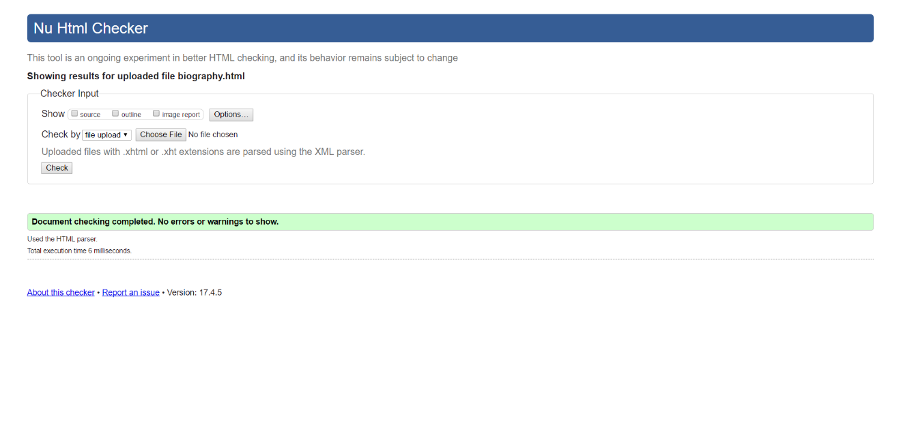

##### Contact page

When the validation test was completed, I found some errors but no warnings and the errors which was there I omitted them and the given below is the result of the test.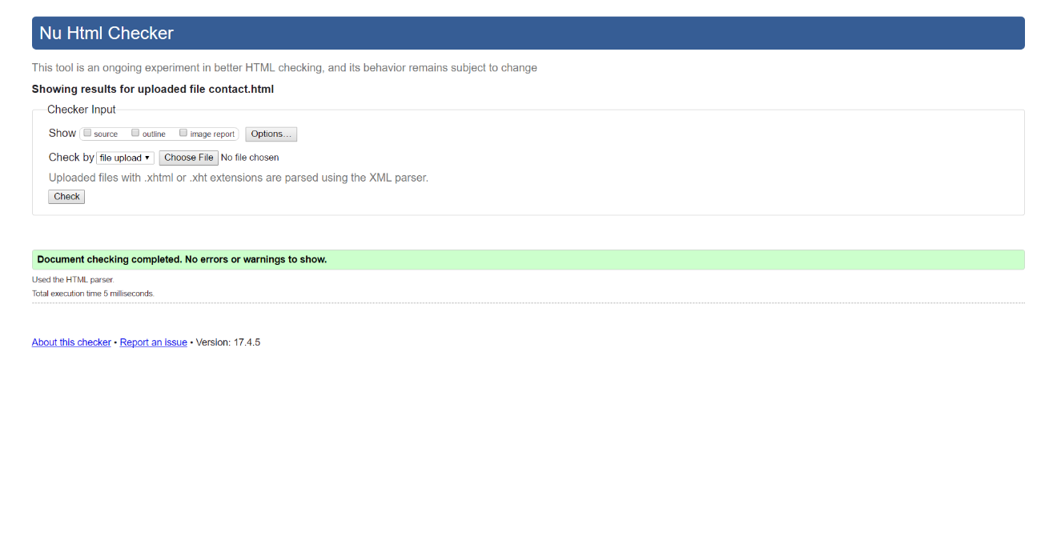

### Test of Css codes of the webpages

##### Home page

During the process of validation test I found some of the errors but there was no warning I have found and hence the result is below as you can see.

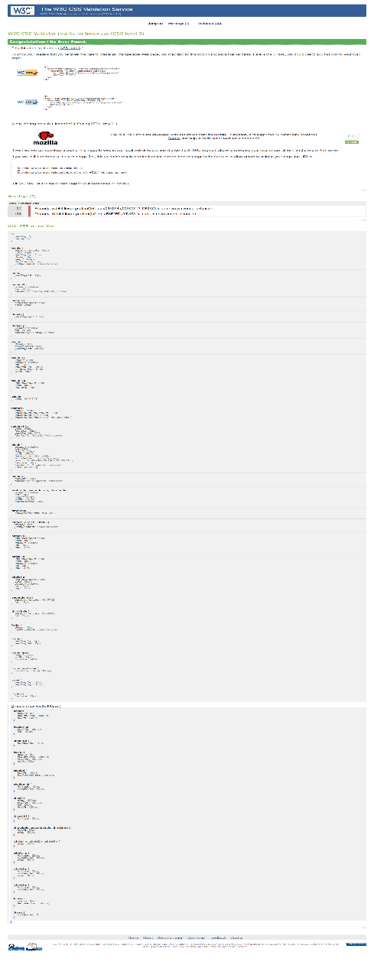

##### CV page

When I was testing the codes for the errors and warning I found some errors but there was absence of warning and the below shown image is the result of the test.

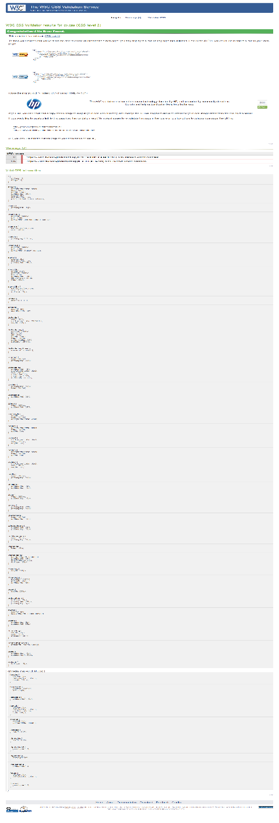

##### Biography page

The moment of validation test I found some errors, I omitted the errors and there was no warning as you can see below there is the result of the validation test.

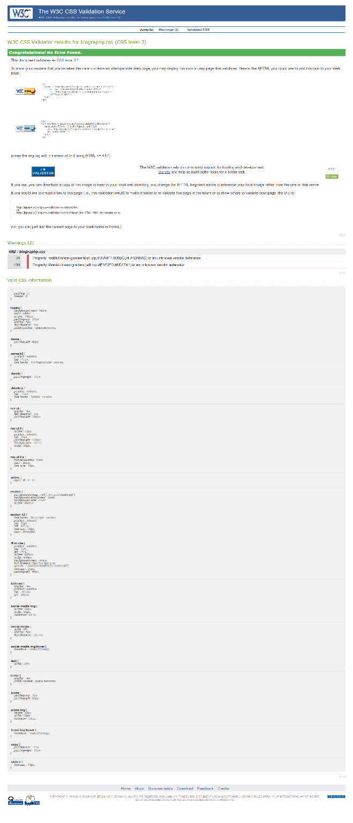

##### Contact page

In the period of the validation test, I found some errors but the warning was not there and the error which was there I omitted it and for the result you can see the given below image.

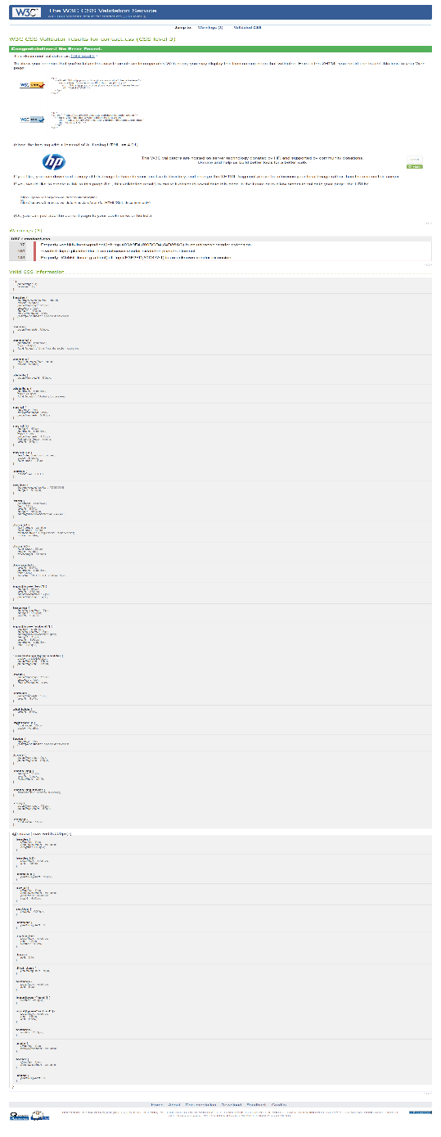

# Conclusion

By the end of the time of making my website I came to the conclusion that I have worked as hard as I could to make my website more attractive by far. I have put my best effort for making my website to look attractive and work efficiently for the user.

As a suggestion I would like to say that languages like java script can be used in this website to make more user friendly and dynamic and also many more animation can be added in buttons.

# Reference

* freshDesignweb. 2017. 50+ Best HTML Resume CV VCard Templates 2016 - freshDesignweb. [ONLINE] Available at: <https://www.freshdesignweb.com/vcard-resume-templates/>. [Accessed 07 April 2017].
* 21 Tips, Tricks & Examples for a Rocking Contact Us Page | WordStream. 2017. 21 Tips, Tricks & Examples for a Rocking Contact Us Page | WordStream. [ONLINE] Available at: <http://www.wordstream.com/blog/ws/2015/03/11/contact-us-page>.

[Accessed 07 April 2017].

* Icon | Semantic UI. 2017. Icon | Semantic UI. [ONLINE] Available at: <https://semantic-ui.com/elements/icon.html>. [Accessed 07 April 2017].